Report on organized Promotional campaigns (act.3.6.) at University Singidunum
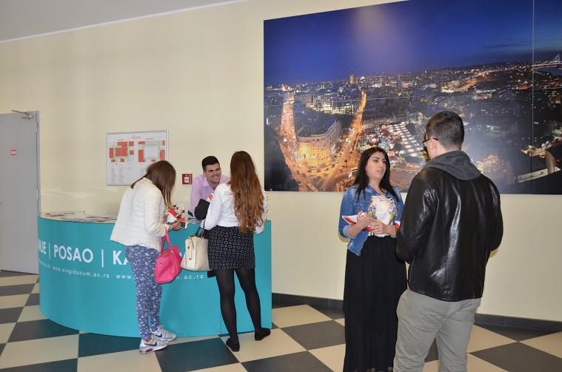
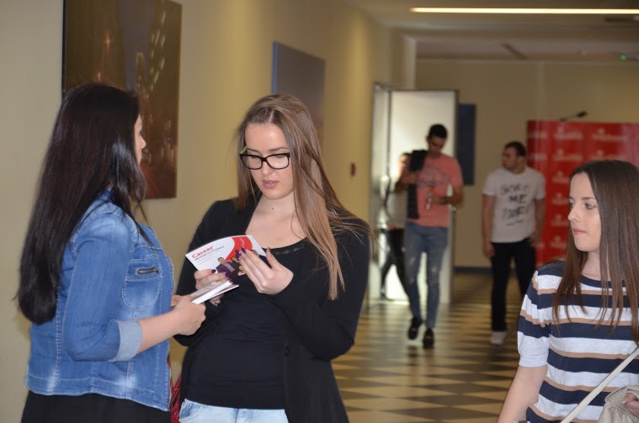
Promo campaign was organized in March 2014.
During 4 hours, Career Center staff and peer educators were distributing new Career Center student brochure and answering student questions related to Career Center services. Career Center student brochure was distributed to all students of 3rd and 4th year of studies. It was also distributed on Future Leaders Conference (acc 120 participants, organized by AIESEC local office), visiting lectures (35 brochures) and internship info day (150 brochures).
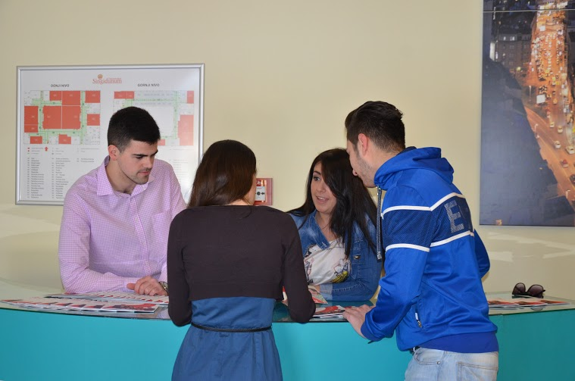
The short lectures were organized by members of the Student Parliament for the students to promote the Centre for Career Guidance and Counseling among colleagues. The aim of the lecture is the convergence of all the possibilities provided by the Center to students, and the benefits that students can enjoy visiting the workshops, seminars, individual counseling, internships etc. In addition, students are educated will continue to peer counseling in the field of career development.
Finally, we have developed new alumni website and new Career Center website is in the process of development.

Report by Marina Savkovic

