Report on (act 3.5.)
Creating careers info points at the faculties at University Singidunum
Info points are set in a new building of Singidunum University, in the prodeans office that is all day open for students. 2 all in one PCs are available for students that are not able to visit Career Center on daily basis, bearing in mind that Student Career Center office is located in old university building (about 3km away from the new one). Info points are equipped by relevant literature and internet access.
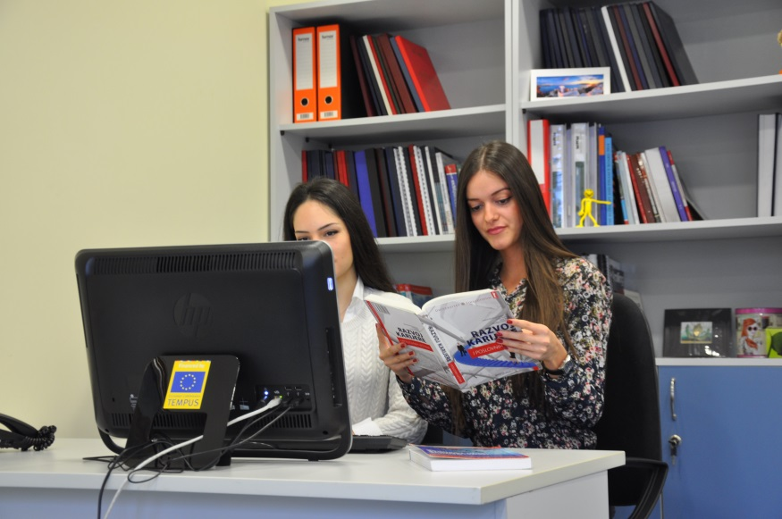

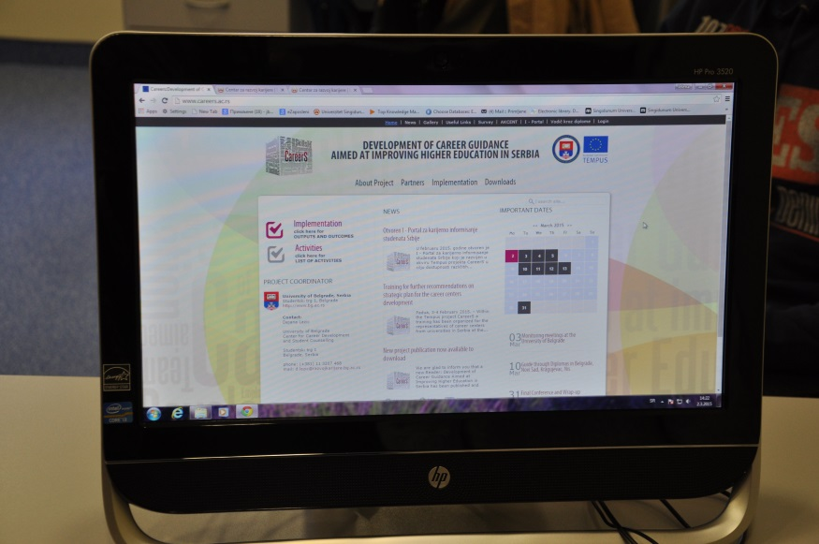
Info points at FEFA are developed and promoted. Information points for career guidance and counseling are located at the Center for career guidance and counseling, and once a week is located in the Student Services. Information point in the Student Services is dedicated to particular topics of practice, cooperation with employers and cooperation with the alumni of the Faculty. Beside the mentioned, it provides all the necessary information to students about their services and activities implemented by the Centre. Center also formed an info point in a student club at the Faculty, with promotional materials that the Centre offers.

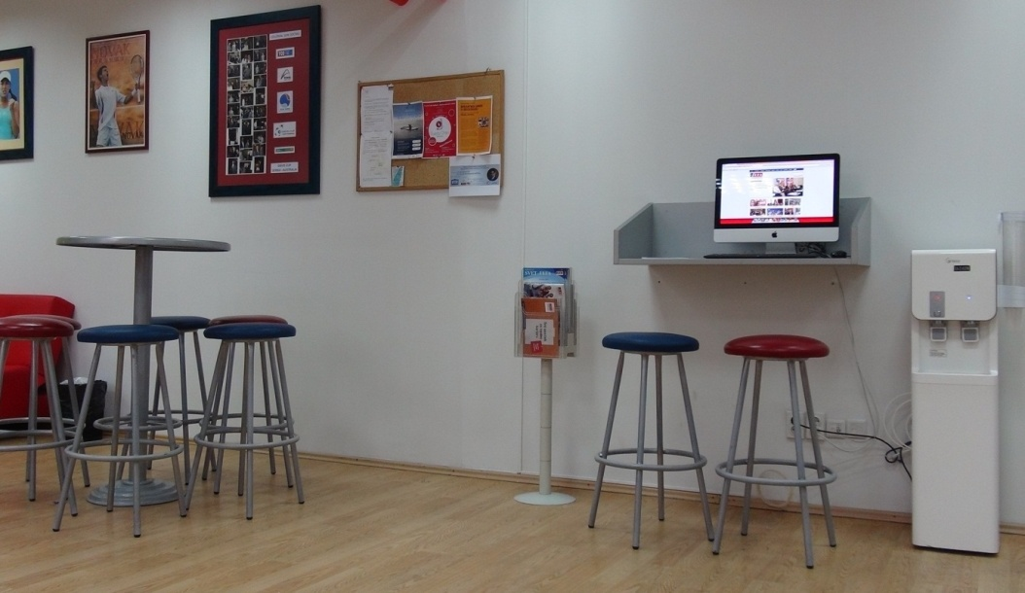
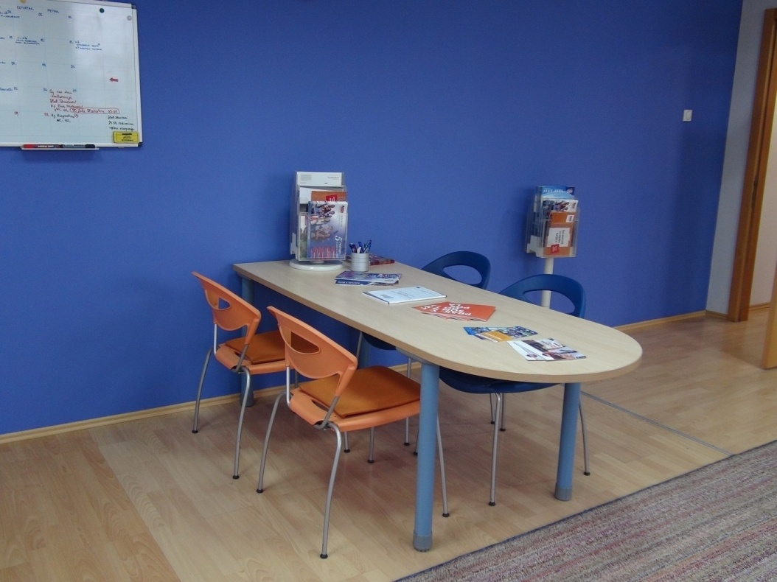

Report by Marina Savkovic

