Report on organized Info session (act.3.4) at University Singidunum

Infosesion was held on 21st of October 2013 at 10:30 am, Singidunum University, Belgrade.

The meeting was attended by Barbara Smorczewska i Agnieszka Dunaj, University of Silesia, Katowice, Poland and the team members of Singidunum University and FEFA for the implementation of the Work Package 3 (Verka Jovanović, Jelena Gajić, Lazar Dražeta, Marko Šarac, Tanja Petričević, Valentina Bošković, Iskra Maksimović, Sandra Nešić, Ivana Perović, Ivan Živanović, Ana Vjetrov and Nađa Vojnović.)

- Singidunum University and FEFA presented the realized activities which have been carried out since November/December 2012 and plans for the implementation of the following activities within Working Package 3.
- Partners from Poland presented the activities of their Career Center and good examples of cooperation with employers. They talked about the Career Center platform which presents “the labor market” or overall supply of employees in Poland and enables students to get necessary information and make contacts with them.
- Our team clarified all doubts and comments submitted by the Polish partners (University of Silesia recommendations for the activity plan of Singidunum University) regarding the planned activities and particularly discussed possibility of the implementation of electronic CV into Career centre which will be user- friendly and therefore could be further processed electronically. Additionally, other issues were: improving signing and visibility of the Career Center location, preparation of the Career Center brochure and highlighting the importance of the textbook Career Development and Business Skills which include three parts: Career development , business communication and business skills.

PROJECT COORDINATOR
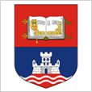 | University of Belgrade  Studentski trg 1  Belgrade, Serbia  + 381 11 3207 463  www.careers.ac.rs

PROJECT PARTNERS
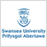
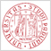
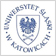
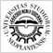

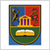


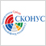
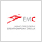

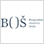
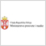
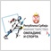
Project: 517119-TEMPUS-1-2011-RS-TEMPUS-SMGR

Report by Marina Savkovic

