Web site www.careers.ac.rs usage during the last year /18.Sept. 2013 – 18.Sept.2014/
Number of accesses: 3 968
Number of interactions: 45, 89% of total users (2 437) interacted with the pages visited (did not leave after visiting single page) during 3 968 sessions in total. Average session duration: 4 minutes and 26 seconds.
Number of pages opened: 17 685. Number of pages opened per session: 4,46.
Number of unique accesses per month: 330, 6
Statistics from where the site was accessed:
Country/Territory … Sessions (percentage of total sessions)
1. Serbia3094(77.97%), 2.Ukraine93(2.34%), 3.India81(2.04%), 4.United Kingdom62(1.56%), 5.Slovakia48(1.21%), 6.Germany47(1.18%), 7.Bosnia and Herzegovina46(1.16%), 8.Macedonia (FYROM)44(1.11%), 9.United States42(1.06%), 10.Italy29(0.73%), 11.Poland28(0.71%), 12.South Africa20(0.50%), 13.Norway19(0.48%), 14.Kosovo17(0.43%), 15.Montenegro16(0.40%), 16.Greece15(0.38%), 17.(not set)15(0.38%), 18.Slovenia13(0.33%), 19.France12(0.30%), 20.Croatia12(0.30%), 21.Philippines11(0.28%), 22.Belgium10(0.25%), 23.United Arab Emirates9(0.23%), 24.Canada9(0.23%), 25.Albania8(0.20%)
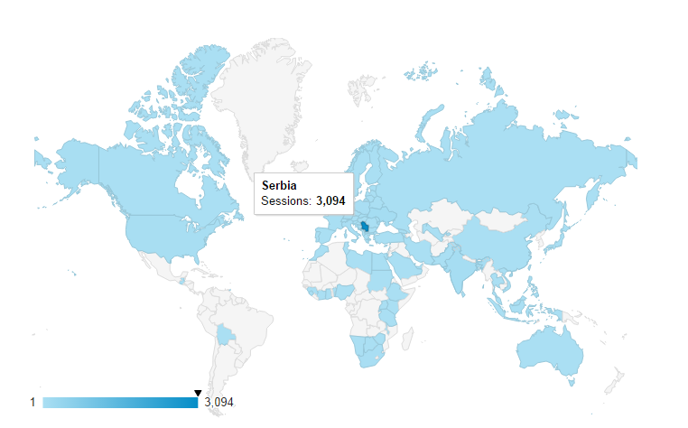
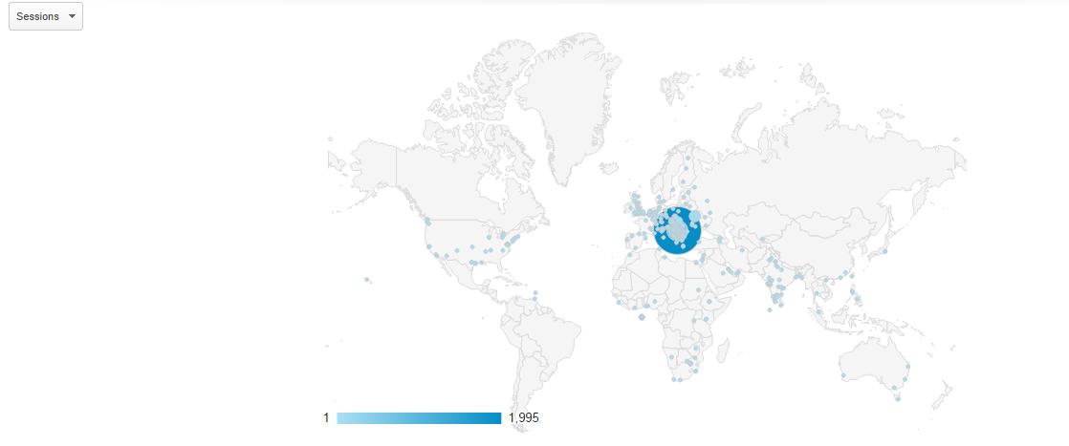
City |  |  | Sessions
 |  | 3,968  % of Total:  100.00%  (3,968) | 3,968  % of Total:  100.00%  (3,968)
1. | Belgrade | 2,375 | 59.85%
2. | Kraljevo | 163 | 4.11%
3. | Novi Sad | 151 | 3.81%
4. | Nis | 137 | 3.45%
5. | (not set) | 109 | 2.75%
6. | Kula | 96 | 2.42%
7. | Kyiv | 90 | 2.27%
8. | Subotica | 48 | 1.21%
9. | Kosice | 46 | 1.16%
10. | Pancevo | 29 | 0.73%
11. | Mumbai | 24 | 0.60%
12. | Skopje | 24 | 0.60%
13. | Kragujevac | 24 | 0.60%
14. | Wuppertal | 23 | 0.58%
15. | Katowice | 22 | 0.55%
16. | Serbia | 20 | 0.50%
17. | Swansea | 14 | 0.35%
18. | Padua | 14 | 0.35%
19. | Banja Luka | 12 | 0.30%
20. | London | 12 | 0.30%
21. | Kruševac | 11 | 0.28%
22. | Sarajevo | 10 | 0.25%
23. | Brcko | 10 | 0.25%
24. | Macedonia (FYROM) | 9 | 0.23%
25. | Zagreb | 8 | 0.20%

