Report on the training at the University of Padova – 5-9 November 2012
Training consisted two major parts:
- KNOW-HOW TRAINING FOR GATHERING AND ORGANIZING CAREER RELATED INFORMATION IMPORTANT FOR STUDENTS / AND ACADEMIC COMMUNITY/ ABOUT LABOUR MARKET
- SEMINAR ON GATHERING AND ORGANISING CAREER RELATED INFORMATION IMPORTANT FOR EMPLOYERS /AND PROSPECTIVE STUDENTS AND PARENTS/ ABOUT UNIVERSITY GRADUATES, STUDY PROGRAMS, HE INSTITUTIONS
----------------------------------------------------------------------------------------------------------------------------------------
KNOW-HOW TRAINING FOR GATHERING AND ORGANIZING CAREER RELATED INFORMATION IMPORTANT FOR STUDENTS / AND ACADEMIC COMMUNITY/ ABOUT LABOUR MARKET
Four days training
It was attended by project team members, representatives of:
- Serbian universities – careers services staff
- Ministries relevant for career guidance on Serbia
that are relevant for implementation of the project activities within the work package 1.
1. Olivera Mijatović, UKG
2. Predrag Vukomanović, UKG
3. Nađa Vojnović, USGD
4. Tanja Petričević, USGD
5. Sonja Šovljanski UNS
6. Olivera Kovačević UNS
7. Snežana Klašnja, MOYS
8. Jana Vlajković, MOYS
9. Ljiljana Todorović, ME
10. Gordana Đurica, ME
11. Dejana Lazić UBG
12. Marija Jovanović UBG
13. Ana Janković Barović UBG
14. Mr Dragoslav Djokić UN
15. Dr Pedja Milosavljević UN

-----------------------------------------------------------------------------------------------------------------------------------------
SEMINAR ON GATHERING AND ORGANISING CAREER RELATED INFORMATION IMPORTANT FOR EMPLOYERS /AND PROSPECTIVE STUDENTS AND PARENTS/ ABOUT UNIVERSITY GRADUATES, STUDY PROGRAMS, HE INSTITUTIONS
One day seminar
It was attended by project team members , representatives of:
- Serbian universities – careers services staff
- Ministries relevant for career guidance on Serbia
- Infostud
- Elektromtromreža Srbije
- Student Conference of universities of Serbia
that are relevant for project implementation of the project activity 2.1 and the rest of the activities in the work package 2.
1. Olivera Mijatović, UKG
2. Predrag Vukomanović, UKG
3. Nađa Vojnović, USGD
4. Tanja Petričević, USGD
5. Sonja Šovljanski UNS
6. Olivera Kovačević UNS
7. Снежана Клашња, MOYS
8. Јана Влајковић, MOYS
9. Ljiljana Todorović, ME
10. Gordana Đurica, ME
11. Dejana Lazić UBG
12. Marija Jovanović UBG
13. Ana Janković Barović UBG
14. Mr Dragoslav Djokić UN
15. Dr Pedja Milosavljević UN
16. Fikret Halilović, SKONUS
17. Tomislav Ćetković, šef obrazovnih sajtova INFOSTUD
18. Dragan Kukić, koordinator razvoja sajtova za zapošljavanje INFOSTUD
19. Marina Tomović, JP EMS
20. Vladimir Krnajski. JP EMS

Speakers and subjects during the training:
- Gilda Rota, Career Service Manager on the Career Services Network, The Coimbra Group and the ReaBP project
- Luigi Fabbris, Professor of Social Statistics on the Repertory of Jobs
- Angelo Di Francia from Almalaurea on the graduates' survey at national level
- Cristina Felicioni from Confindustria Padova on the labour market needs
- Erica Bezzon and Professor Luigi Fabbris on the Labour Market Observatoria
- Anna Boaretto on the Internships and Jobs web platform
- Barbara Cossu from AIESEC on the student career associations
- Leonardo De Luca from JEST on the engineering student association for career opportunities
- Davide Bresquar from MB Scambi Culturali on the graduates' employability from the perspective of the employers
- Lorenzo Amadei from CUOA on the Career Centres and Social Media
The training course is held in Aula Canova, Palazzo Storione, Riviera Tito Livio 6.
This training is part of the working packages devoted to developing a system of organized and accessible career information relevant for university students and employers in Serbia and developing of career guidance and counselling aimed at improving higher education in Serbia.

Training agenda
Training at the University of Padova
the Career Service of the University of Padova
Palazzo Storione, Riviera Tito Livio 6, 35122 Padova

Monday, the 5th of November 2012 – Aula Canova (close to the office – Galleria Storione, 9)

10.30 – 12.00 Morning Session Welcome to the University of Padova Training Programme
10.30 – 11.00 Greetings from the Rector’s Delegate for International Relations
11.00 – 11.15 Video presentation of the University of Padova
11.15 – 11.30 Presentation of the Training Programme
11.30 – 12.00 Presentation of the Career Service Office: personnel, activities and practical information
12.00 – 14.00 Lunch
14.00 – 16.00 Afternoon Session
14.00 – 15.00 Guided tour of the Bo Palace

Tuesday, the 6th of November 2012 – Aula Canova

10.00 – 12.00 Morning Session – Labour Market Observatoria
12.30 – 14.30 Lunch
14.30 – 16.30 Afternoon Session
14.30 – 15.45 Seminars with students, meetings, Action 8, Career Days, recruiting days
15.45 – 16.30 Pilot service on the career guidance; best practices

Wednesday, the 7th of November 2012 – Aula Canova

10.00 – 12.00 Morning Session
10.00 – 11.15 tools for managing labour market offers
11.15 – 12.30 Guided tour of the Botanical Garden of the University of Padova http://www.ortobotanico.unipd.it/en/index.html
12.30 – 14.30 Lunch
14.30 – 16.30 Afternoon Session: Careers and occupations list - Repertorio delle Professioni: the experience of the University of Padova

Thursday, the 8th of November 2012 – Aula Nievo (Bo Palace – Via 8 Febbraio 1848, Nr. 2)

10.00 – 12.00 Morning Session
10.00 – 11.00 Career Centre Networks : Coimbra Employability and Career Guidance Task Force and the EUE-Net University Entreprise Network
11.00 – 11.45 Intervention from Aiesec - Association Internationale des Etudiants en Sciences Economiques et Commerciales
11.45– 12.30 Intervention from JEST – Junior Enterprise Engineering and Management
12.00 – 14.00 Lunch
14.00 – 16.00 Afternoon Session
Web 2.0: social media tools and dialogical opportunities University Career services

Friday, the 9th of November 2012 – Aula Canova
09.30 – 12.30 Morning Session - Graduates on the labour market
09.30 – 11.45 The graduate’s employability from the employers’ perspective: studies, surveys, analysis and
11.45 – 12.30 Raising the Employers' Awareness about the Bologna Process – presentation of the project ReaBP

12.30 – 14.30 Lunch
14.30 – 16.00 Afternoon Session
14.30 – 15.30 Presentation of the CareerS’ draft of the questionnaire for survey on employers and discussion on the principles for labour market analysis
15.30 – 16.45 Final discussion and evaluation of the training.

Evaluation
Based on the 17 filled evaluation sheets the average grade of the training is: 4.74

# 1 indicates strong disagreement; #2 indicates disagreement; #3 indicates some agreement; #4 indicates agreement; and #5 indicates strong agreement.

Statements |  | Average grade
1 | Workshop objectives were clearly described | 4.70
2 | Time was allotted well for the workshop and the delivery was well paced | 4.88
3 | Trainers focused on participant needs | 4.65
4 | Workshop materials were adequate and appropriate | 4.70
5 | The facilitators encouraged interaction, participation and questions | 4.70
6 | Workshop’s facilities and logistical arrangements met my needs | 4.82
7 | The duration of the workshop was appropriate | 4.76
Among the answers of the participants to what learning from the training there were following:
- Labour market observatory and repertoire of professions
- Social network information
- Labour market analyses
- Pharos Questionnaire (two times)
- Employers questionnaire (two times)
- Lecture about raising employers awareness about Bologna process
- Tools for managing job offer

Dissemination - Italy
http://www.unipd.it/en/international-academic-networks
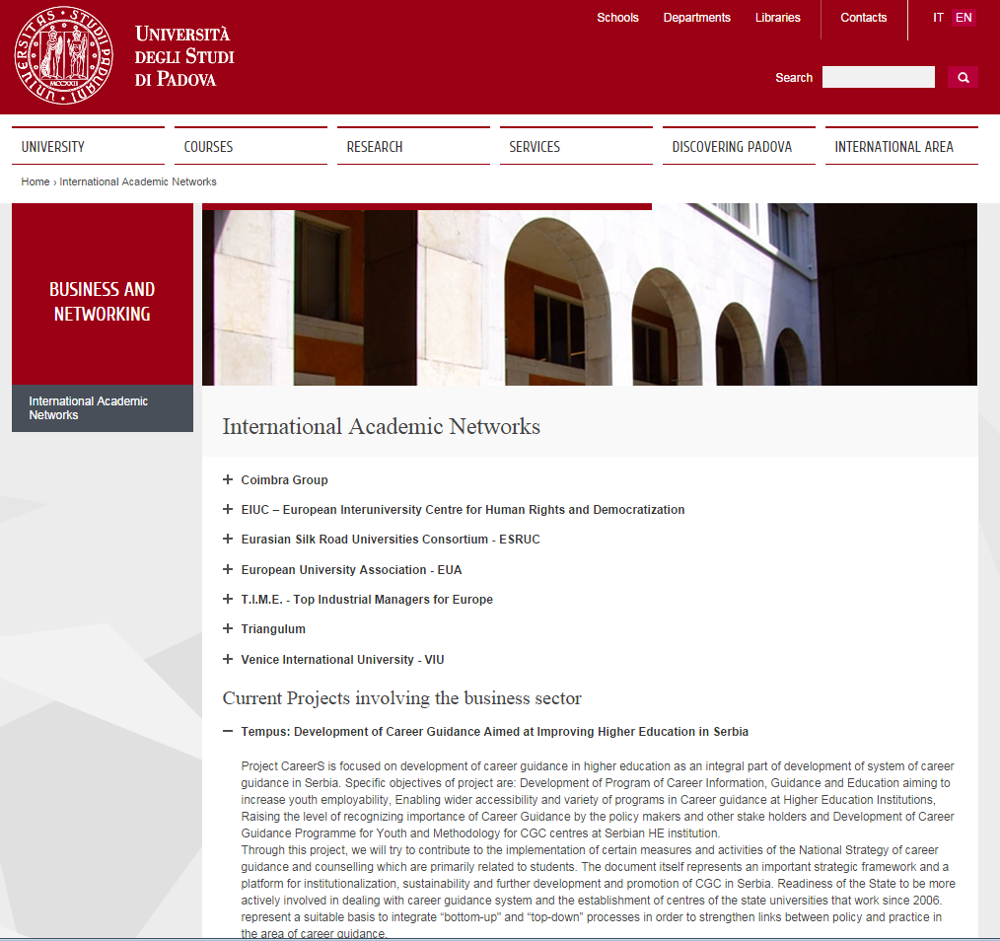
http://www.unipd.it/ilbo/content/una-delegazione-dei-career-service-delle-universita-della-serbia-visita-padova
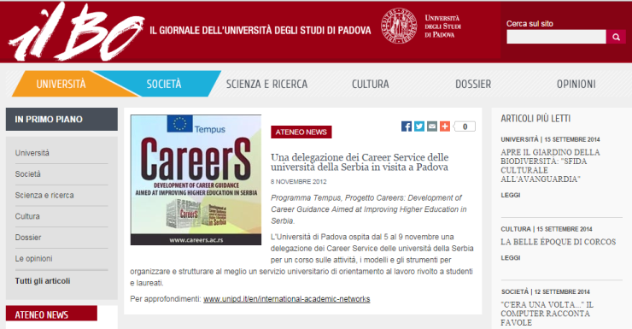
http://www.ilvivipadova.it/programma-tempus-progetto-careers-development-career-guidance-aimed-improving-higher-education-serbi


