REPORT ON PROMOTION OF DEVELOPED E-SERVICES, ACT.5.7.

Panel discussion dedicated to the role of ICT in career guidance and counseling in higher education was organized on March 31, 2015 in the building of the University of Belgrade.
Interested colleagues and employers had the opportunity to discuss the importance of software for the administration of internships, the developed platform for administration, recruitment and pre-selection of candidates, developed information systems and databases that should help employers to find and understand better the information about the differences that bring the reformed curricula, diploma supplement, etc. . The question that was also launched was how informative and accessible are the sites for career development for employers interested in cooperation with university career centers. Introductory presentations were dedicated to informing students, teachers and other staff of the newly developed electronic services dedicated to career informing, advising and career education. One of the topics was also the question to what extent the existing sites of the Centers for career development are responsive to the needs of students and their dilemmas regarding career development. The panelists were representatives Career Development Centers from University of Belgrade, University of Novi Sad, University of Nis, University of Kragujevac and Singidunum University.

Invitations for the panel with the announcement which included links to the websites of university career centers has been sent to more than 600 email addresses, and panel was attended by more than 30 representatives of students, business community, academic community and media.

Agenda:
- Marija Jovanovic, University of Belgrade, I-portal for career informing students / www.careers.ac.rs /iportal.html, Guide diplomas / www.careers.ac.rs/vodic-kroz-diplome.html, new functionality on the site www.razvojkarijere.bg.ac.rs - base operations,internships, scholarships, training etc., the user accounts, e-library, mailing lists, sections Virtual Advisor Guide and career development during their studies
- Sonja Šovljanski, University of Novi Sad, the new website www.razvojkarijere.uns.ac.rs and developed software for facilitating the selection of candidates, virtual interviewer
- Milica Spasojevic, University of Kragujevac, the new website www.razvojkarijere.kg. ac.rs and website development www.studentskapraksa.com
- Milena Prvulović, University of Nis, the new website www.karijera.ni.ac.rs
- Marina Savković, Singidunum University, intranet for students, electronic services to support the work of the university career center
- Milena Vujovic, University of Belgrade, software development for career planning

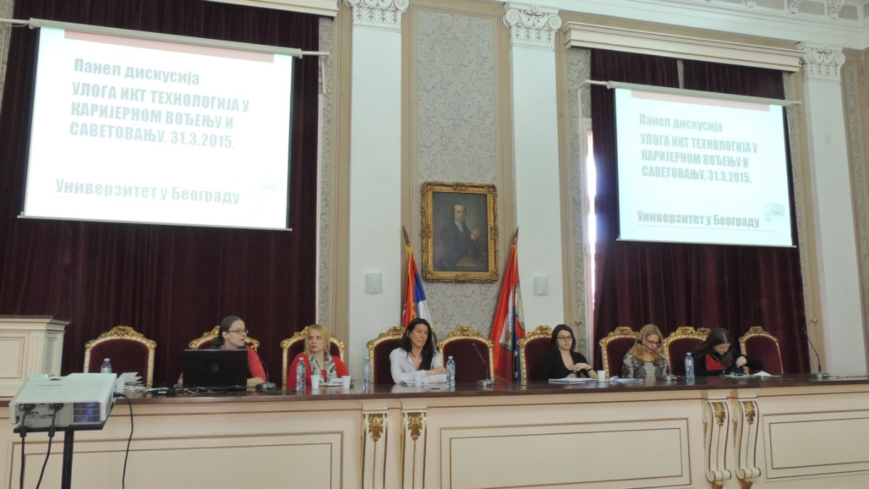
Some of the media that reported on developed ICT are the following:
- Radio Television Vojvodina on 30 March 2015
- New agency BETA on 31 April 2015
- Internet portal AKTER on 1 April 2015
- New agency FONET on 1 April 2015
- TV Kopernicus on 1 april 2015
- Article about the panel was published in the newspaper PROSVETNI PREGLED on 9 April 2015.


In February 2015 Press release about launched I-portal –has been sent published on the project website, sent to selected list of media and all project partners placed the baner on their websites to be linked with http://www.careers.ac.rs/iportal.html
Social media has been used to promote the portal to students and the page has been visited in the period from 15 February to 15 April 1704 times (based on the Google analytics).
Information about it has been published on the numerous websites within the relevant sections, below are some of them:
- http://www.rtv.rs/sr_lat/mladi/obrazovanje/portal-za-karijerno-informisanje-studenata_570553.html
- http://ec.org.rs/i-portal-za-karijerno-informisanje-studenata/
- https://www.facebook.com/centarram/posts/805934629489556
- http://www.vesti.rs/Vojvodina/Portal-za-karijerno-informisanje-studenata.html
- http://www.nsreporter.rs/vesti/portal-za-karijerno-informisanje-studenata/
- http://news.burina.net/news/portal-za-karijerno-informisanje-studenata
- http://webium.in/srbija/portal-za-karijerno-informisanje-studenata-2015-02-21
- http://www.mladism.rs/info/informisite-se-o-buducoj-karijeri/
- http://praksa.fon.bg.ac.rs/dokumenta/2015/02/PregledvestiCzRKUniBgd-FON.docx
- http://www.najvesti.com/gradovi-srbija/grad-novi-sad/2279126-Portal-za-karijerno-informisanje-studenata.html

On 27th February 2015 project representative participated at the Panel discussion on "Harmonisation of the higher education system with the needs of the labour market" at the Chamber of Commerce of Serbia in Belgrade organised within “Student economic and political forum” by Centre for education and social emancipation of young people, Belgrade.
Participants in the panel were:
- Prof.dr Slobodan Pajovic, Rector of Megatrend University
- Dr Milovan Suvakov, special advisor to the Minister of Education of Serbia
- Snesana Klasnja, assistant to Minister of Youth
- Ognjen Popovic, vice-president for cooperation with industry of the Student Parlament of University of Belgrade
- Marija Jovanovic, University of Belgrade Centre for Career Development

Among other topics, e-services developed within the Tempus project CareerS were promoted on this occasion to around 80 students from various faculties which are active members of the representative bodies of students.
50 pieces of Project CareerS brochure was disseminated on this occasion along with other materials about programs and activities of University of Belgrade Career Centre.

