Round Table for Discussing First Drafts of the Program and Methodology of Career Guidance and Counselling for people aged 19-30

On Tuesday February 25th 2014, in the Rectorate of the University of Belgrade, was organized a Round table within the Tempus project CareerS – Development of career guidance and counselling aimed at improving higher education in Serbia. The Round table was dedicated to public discussion of the two documents drafted within the Work Package 6 of the project CareerS: Program of Career Guidance and Counselling for people aged 19-30 and Methodology of Career Guidance and Counselling for people aged 19-30. Drafting of Program and Methodology was planned within the Action Plan for the implementation of the Strategy of Career Guidance and Counselling in the Republic of Serbia.

Meeting Agenda

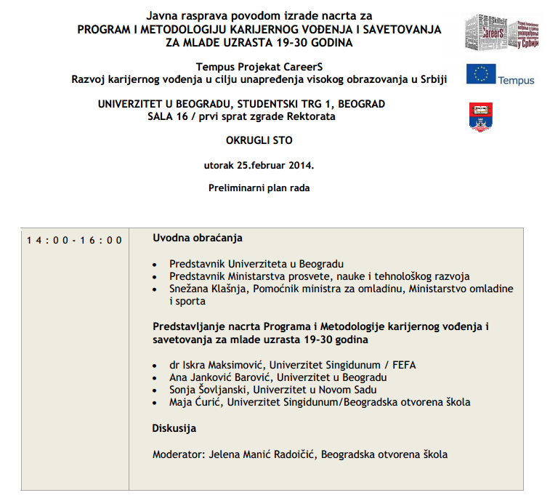

Meeting Minutes

Participants were welcomed by Mrs. Nada Kovacevic, PhD. Vice-Rector for Education at the University of Belgrade and Mrs. Snezana Klasnja, Assistant Minister for Youth in the Ministry of Youth and Sport of the Republic of Serbia. After that, the team of experts who were directly engaged in the developing of documents addressed to participants: Mrs. Iskra Maksimovic, PhD. University of Singidunum/FEFA, Mrs. Ana Jankovic Barovic, University of Belgrade, Mrs. Sonja Sovljanski, University of Novi Sad and Mrs. Maja Curic, University of Singidunum/Belgrade Open School. The Round table was moderated by Jelena Manic Radoicic, coordinator of Centre for Career Guidance and Counselling of Belgrade Open School.

After the discussion the vivid debate took place. Experts from various institutions presented their comments and ideas regarding the solutions presented in the documents. The main comments considered the scope of the document. Many experts and representatives from different institution raised the question whether this document should address all young people aged 18-30 or only student population. Opinion that document should focus more on university engaged youth population rather than all young people aged 19-30 dominated and it was later on accepted by the authors. Suggestions to better define career counselling in relation to psychological and other forms of counselling were also given. Question about the status of standards and their normative potential was also raised as very important issue that should be resolved to reach the final version of documents or one document, that could be acceptable among all relevant stakeholders and be primarily oriented toward university students population and career development centres.

Professional and scientific public that attended the discussion gave useful comments for improvement of Program and Methodology of Career Guidance and Counselling for people aged 19-30 that will be included in the development of final documents. Recommendations resulting from this occasion, especially the ones referring to improving the quality of career guidance and counselling for young people will contribute to further development of national system of career guidance and counselling in the Republic of Serbia.

Meeting Participants

The discussion was attended by about 60 persons.

- Vesna Cekic, National Employment Service
- Jadranka Radojicic, National Employment Service
- Gordana Lazic, National Employment Service
- Jelena Vulinic, National Employment Service
- Vesna Sisel, National Employment Service
- Ljiljana Pavlovic, Serbian Association of Employers
- Tatjana Prijic, Ministry of Labour, Employment and Social Policy
- Cris Cardew, University of Swansea
- Zoltan Denes, University of Padua
- Gilda Rota, University of Padua
- Agnieszka Dunai, University of Silesia
- Barbara Smorowsieska, University of Silesia
- Marija Radovanovic, GIZ
- Milena Muvgonic, BEST (students’ organization)
- Bojana Nikolic, JP EMS
- Dragoslav Peric, JP EMS
- Ljiljana Todorovic, Ministry of Education
- Gordana Djurica, Ministry of Education
- Miodrag Lazic, University of Nis
- Mihajlovic Dubravka, University of Belgrade, Faculty of Philosophy
- Milena Skaljac, Tempus Foundation
- Marko Bankovic, Euroguidance
- Sonja Sovljanski, University of Novi Sad
- Nikola Koruga, Adult Educaition Society
- Marija Jovanovic, University of Belgrade
- Dejana Lazic, University of Belgrade
- Milena Dimitrijevic, University of Belgrade
- Ana Jankovic Barovic, University of Belgrade
- Marija Petronijevic, Ministry of Youth and Sport
- Igor Petrovic, ADECCO
- Sanda Radan, ELSA Belgrade (students’organization)
- Nevenka Ivosevic, ELSA Belgrade (students’organization)
- Nadja Petrovic, BEST Belgrade
- Milica Milenkovic, University of Kragujevac
- Predrag Vukomanovic, University of Kragujevac
- Jelena Civljak, University of Nis
- Danijela Dakic, Infostud d.o.o
- Tatjana Vidakovic, Infostud d.o.o
- Slavko Pesic, Faculty of Mechanical Engineering in Belgrade
- Maja Curic, Faculty of Media and Communication
- Nadja Vojinovic, Singidunum University
- Sandra Nešić, Singidunum University
- Jelena Gajić, Singidunum University
- Ana Vjetrov, Singidunum University
- Vesna Djukic, Belgrade Open School
- Marija Srećković, Inventiva NGO
- Jelena Dimitrijević, Inventiva NGO
- Snezana Klasnja, Ministry of Youth and Sports
- Saša Niklanović, expert
- Jadranka Dimov, expert
- Tomislav Cetkovic, Infostud d.o.o.
- Darko Stokjović, Infostud d.o.o.
- Nada Kovačević, University of Belgrade
- Zrnović Stefan, BEST Belgrade
- Jelena Manic Radoicic, BOS
- Tamara Kljajic, BOS
- Iskra Maksimovic, Singidunum University

Evaluation

Participants evaluated certain aspects of the Round table giving the 1 as the lowest and 5 as the highest grade on the scale. Average grades are represented below:

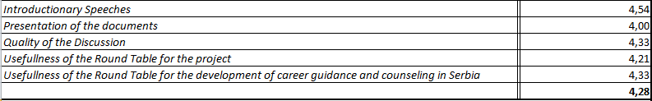

Overall score of the round table was 4,28.

