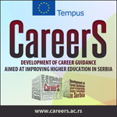
Report

TRAINING AT UNIVERSITY OF SWANSEA – TEMPUS PROJECT CAREERS, 2012
8th May – 14th May 2012
The trainings were held at University of Swansea over the period of 8th to 14th May 2012.
The training was aimed at Career Service Staff, and included workshops on Counseling Theories Introduction and Discussions, IT platform and e-guidance.
Participants in the training
 | Name and surname | Institution
1 | Olivera Mijatovic | University of Kragujevac
2 | Milica Milenkovic | University of Kragujevac
3 | Dejana Lazić | University of Belgrade
4 | Marija Jovanović | University of Belgrade
5 | Jelena Kurjak | University of Belgrade
6 | Milena Dimitrijević | University of Belgrade
7 | Borivoje Baltezarević | University of Niš
8 | Jelena Čivljak | University of Niš
9 | Dragan Janković | University of Niš
10 | Nađa Vojnović | University Singidunum
11 | Iskra Maksimović | University Singidunum
12 | Sonja Šovljanski | University of Novi Sad
13 | Snežana Klašnja | Ministry of Youth and Sport
14 | Milan Radonjić | University of Belgrade

Participant on the session on 9th May from Belgrade / conference
- Jelena Manic, Belgrade Open School
- Itana Miljanic, Belgrade Open School
- Dubravka Mihajlovic, University of Belgrade
- Ana Jankovic Barovic, University of Belgrade
- Semir Kambovic, State University Novi Pazar

TRAINING PROGRAM TIMETABLE

 | Tuesday, 8 May | Wednesday, 9 May | Thursday, 10 May | Friday, 11 May | Saturday, Sunday | Monday, 14 May
10.00 -12.00  Morning session | Welcome  Career guidance delivery at university  (organization, structure, who is doing what, how each service works) | Theories and practice in Career  Counselling and Career Education | Group counseling / Couching  Intro to E-services of Career Centre | Individual micro project worktime | Free time | Individual sessions
12.00 – 13.00 Break | Campus tour | Lunch | Lunch | Lunch | Lunch | Lunch
13.00 – 15.00  Afternoon session | Shadowing work of services (in groups) | Practice observation  a) career counseling in-depth session  b) attending workshop for students | Demonstration of online tools and software | Group micro project worktime | Free time | Presentation of microprojects
15.00 – 16.00 | Break | Break | Break | Break | Break | Farewell tea
16.00 – 18..00  Evening session | Career Information Services (System and technology analyses) | Discussion on topics and tools for career education and counseling programs | On-line guidance tools in Career services | Free time | Free time

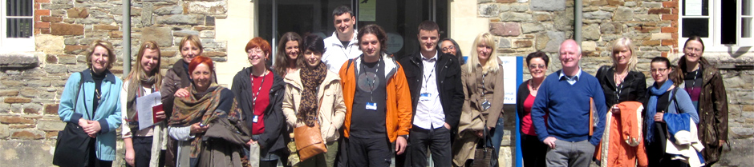
PRESS RELEASE:

TRAINING AT THE UNIVERSITY OF SWANSEA

Swansea, 14 May 2012 – During the period from 8th until 14th of May 2012 the group from Serbia attended training at University of Swansea Careers and Employment in UK. The Career Guidance and Counselling training and study visit at the University of Swansea consisted of a structured program with introductory, practical and advanced components for the key staff from the university career services from the University of Belgrade, University of Novi Sad, University of Nis, University of Kragujevac, University of Singidunum and a representative of the Ministry of Youth and Sport, a relevant national institution for the implementation of the National Strategy of Career Guidance and Counselling of the Republic of Serbia. Training was part of one of the project work-packages devoted to development and strengthening capacities of university career services. Goal of the training was to train and introduce the key staff with best practices of our EU partners in the field of delivery of career guidance at higher education institutions and improving relations of policy makers and practitioners.
During the following period and with the continuous support and cooperation Serbian university career services plan to develop e-services and various employability programs to achieve one of the project objectives - to enable wider accessibility and variety of programs in Career guidance at Higher Education Institutions. Project CareerS - DEVELOPMENT OF CAREER GUIDANCE AIMED AT IMPROVING HIGHER EDUCATION IN SERBIA - is focused on development of career guidance in higher education as an integral part of development of system of career guidance in Serbia.

Dissemination UK
http://www.swansea.ac.uk/media-centre/latest-news/frombelgradetobrynmill-serbiancareersexpertsvisitswansea.php
http://www.thisissouthwales.co.uk/University-s-job-experts-help-Serbian-visitors/story-16086756-detail/story.html
http://www.flickr.com/photos/swanseauniversity/sets/72157629724805846/

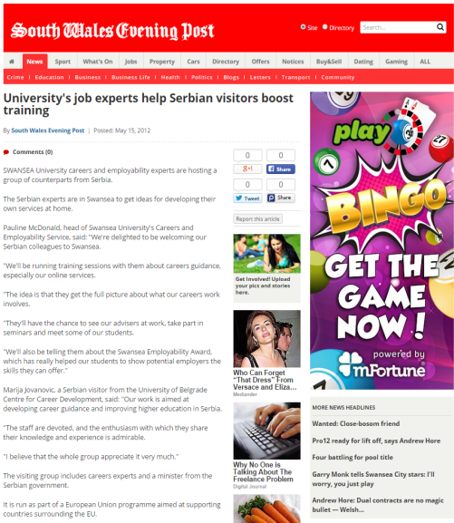

Evaluation
Average grade on all evaluated training sessions was: Very Good. All participants were satisfied with the received trainings, and expressed the will and motivation to apply new knowledge, especially in the area ofCounseling Theories, e-guidance, web platforms (PebblePad) and general e-services development.
Training session 1
8th May 2012
Based on the 11 filled evaluation sheets, the average grade of training is: Very good

Other evaluations were descriptive.
- What participants enjoyed the most | - Career services, using social media, discussing about presentation/voting  - Jo Davies’ session on Career Information Services Presentation by Jo Davies  - The interactivity  - Theories and practice in career counseling  - E- portfolio
- What participants felt they could introduce to their service? | - IT support platform  - Video CVs  - Careers theory and practice  - Elements of GoWales in collaboration with employers  - Online gadgets that combine virtual elements and new techniques with career guidance, which essentially emulate person-to-person conversation.
- Was there anything that you would like to have seen included but was missing from the day? | - More info on online services  - Career guidance interviews

Sessions
Session | Session included | Objectives
Morning session | - Swansea University/Careers Service overview  - GoWales website and presentation
Afternoon session - Shadowing work of services (in groups) | - Individual observations of Careers guidance interviews, maximum of 6 interviews (parallel)  - Careers Module embedded into the academic Course – Overview  - Video of workshop  - Assess students presentations. Reflect on how to implement in Serbia | - Be aware of how Careers Education can be embedded into a course  - Be aware of the importance of the student taking control of their Career planning  - Be aware of the importance of including academic staff and employers  - Understand about how to assess assignments.
Evening session - Career Information Services (System and technology analyses) Demonstrations with practical exercises | - Overview  - Prospects website – how we use it  - AGCAS community and website  - Swansea Careers website, FB, Twitter, Blog, (Interactive Career Planning)

Training session 2
9th May 2012
Based on the 5 filled evaluation sheets, the average grade of training is: Very good

Other evaluations were descriptive.

- What participants enjoyed the most | - Workshops  - Exploring site: http://destinations.swan.ac.uk/units/topics.shtml  - Video conference – content and format  - Theories  - Web team members consultations
- What participants felt they could introduce to their service? | - Counseling theories  - E-services  - Web site
- Was there anything that you would like to have seen included but was missing from the day? | - n/a

Sessions
Session | Session included | Objectives
Morning session | - Theories and practice in Career Counseling and Career Education
Afternoon session - Practice observation – Swansea University Careers Advisers | - Individual observations of Careers guidance interviews, maximum of 6 interviews (parallel)  - Career Counseling session  - Workshop exercise continued
Evening session | - Destinations, Windmills. Demonstration and practical exercises (tbc)  - Discussion on topics and tools for career education and counseling programs.
Training session 3
10th May 2012
Based on the 11 filled evaluation sheets, the average grade of training is: Very good

Other evaluations were descriptive.

- What participants enjoyed the most | - PebblePadwebfolio  - Afternoon session and practical work  - Theory debates  - Teaching and learning strategies, workshop and e-services.  - Morning session and information on how to organize CV workshops
- What participants felt they could introduce to their service? | - Profiling for Success exercises  - E-counselling  - Prospect Planner or other similar web service  - Career Guidance for reserachers
- Was there anything that you would like to have seen included but was missing from the day? | - More work on e-services

Session | Session included | Objectives
Morning session | - Group counseling / Coaching – Group sessions  - Intro to E-services of Career Centre  - Interactive Career Planning resources – demo andpractical exercises
Afternoon session - Demonstration of online tools and software (mostly practical exercises) | - PebblePad practical exercise, create e-portfolio for this training and for project | - Gain an understanding of the importance of online resources  - Have practice in using tools, creating, sharing and assessing  - An understanding of formative assessment  - An understanding of the importance of the student taking control.
 | - E-guidance, Vacancies and booking system. How a student uses this resource | - Understand how an e-guidance system works  - Understand how a vacancies system works  - Understand how students and staff book and manage appointments and employer presentations.
Evening session - Employability Award – Overview, how it works and how it was created | Profiling for Success, Prospects Planner, GradintelPractical exercise | - Understand how an employability award works  - Be aware of the online resources available to students  - Be aware of how reflecting on experience is important in self learning

Training Session 4
11th May 2012
Sessions
Session | Session included | Objectives
Morning session | - Xerte – open source tool for creating e-learning courses (PC1) | - Understanding of how to use Xerte to create employability courses
Afternoon session | - IndiE-services of University Career Centres.  - Communications – language of benefit for students, employers, academic staff, stakeholders – promo materials.
Evening session

Training Session 4
12th May 2012
Sessions
Session | Session included | Objectives
Morning session | Individual and/or group projects work – presentation preparation
Afternoon session- Short presentation of Individual and/or group projects | Relation of policy makers and practitioners – to matrix or not to matrix – word on standards in career guidance programs. | - Be aware of quality systems and how they operate in HE Careers  - Be aware of the process that matrix follow
 | - E-services of University Career Centres.  - Communications – language of benefit for students, employers, academic staff, stakeholders – promo materials. | - Understanding of the importance of relationships that need to exist between Careers staff, Academic staff, students and employers  - Understanding of effective marketing to key groups
Evening session

